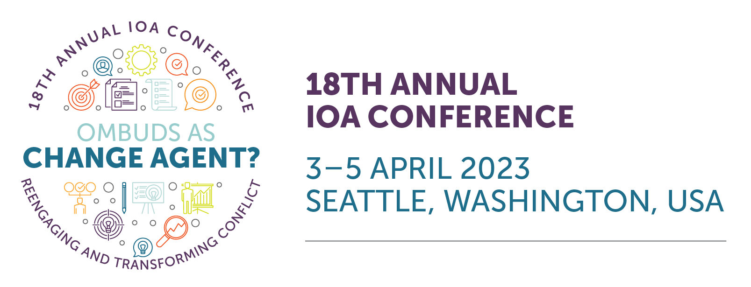
PDH Tracking Sheet for CO-OP® Recertification
2023 IOA Conference
To all Certified Organizational Ombuds Practitioners,
Continued use of the CO-OP® credential requires recertification every four years. Recertification demonstrates that the practitioner has kept abreast of developments in the field and has maintained a level of professional knowledge consistent with status as a certified practitioner.
Below you will find a Professional Development Hour (PDH) Tracking Sheet for verification of attendance at each of the sessions you attend. Each of these sessions has been reviewed by the recertification committee of the CO-OP® Board to ensure that they meet the requirement of falling within one of the seven testing domains. Also, each session has been assigned a specific number of PDH. Please note that the maximum amount of PDH to be claimed from once conference is 15, regardless of how many sessions you attend. Also note that some of the sessions will be recorded and available for viewing after conclusion of the event.
You are responsible for maintaining this document for recertification purposes. If your application is selected for audit, you will be required to provide documentation to verify your attendance.
Day One | 3 April 2023
Session | PDH | Attended
KEYNOTE: Amy Gallo | 1
Session Block 1 | 11:30 AM – 12:30 PM
Ombuds “Pinspiration” and Change Agent in the Tech Sector: Introduction to the Pinterest Ombuds Program | 1
A Novel Idea for Reengaging Those In Conflict | Pete Alexander | 1
The Humility Project: Thinking of Our Ombuds’ Selves Less | Tessa Byer | 1
Try Again: Reengaging with Games in Ombuds Marketing & Practice | David G. Schwartz | 1
Session Block 2 | 2:00 PM – 3:00 PM
2A Creating our Own User Manuals: Ombudsing with Neurodiversity in Mind | Israela Brill-Cass | 1
2B Being a Change Agent for Diversity and Inclusion Using Data and Change Management Methodology | Alexandre St-Jean, Lianna Ferran, & Stephanie Kim | 1
2C Transforming Tolerance into Belonging | Kimberly Howard | 1
2D Moral Conflict: Creating Dialogue Across Values and Beliefs | John Howard | 1
2E Ombuds Bringing Change: Stories Across Continents and Sectors | Wiktoria Maslowska | 1
DAY TWO | 4 April 2023

KEYNOTE: Sarah Freiseleben | 1
Session Block 3 |9:45 AM—10:45 AM
3A Dancing to the Edge of Neutrality | Jennifer Mahony, Linda Brothers, & Katie Manderson | 1
3B No Prince(ss) is Coming; Specific Techniques for Ombuds-led Culture Change | Dr. Susan Raines | 1
3C Trusted Navigation and Career Support: The Career Counseling Ombuds | Don Lubach | 1
3D Creating Change When the Sun Doesn’t Shine in Your Institution | Sarah Klaper, Katherine Greenwood, & Jessica Kuchta-Miller | 1
3E Divided We Fall: Tackling Polarization in the Workplace | Rachel Nicholson & Christopher Artis | 1
Session Block 4 | 11:00 AM—12:00 PM
4A Ripped from the Higher Ed headlines: How Might the Ombuds Help? | Julia Farmer | 1
4B Powerful Oral and Data Storytelling: Encouraging Systemic Change by Communicating Impact | Tina Hinh & Balint Balassa | 1
4C How Ombuds Programs Empower D&I and the Worker Voice | 1
4D Who are We, and What Do We Do? Insights from the 2022 Practice Survey | Dr. Jennifer Schneider, Dr. Timothy Hedeen, Dr. Mary Rowe, & Dr. Hector Escalante | 1
4E Getting a CLEW: Ombuds Facilitating Change and Bridging Gaps Via New Chair Leadership Engagement Workgroup | Melanie Jagneaux & Alicia Booker | 1
Session Block 5 | 1:15 PM—2:15 PM
5A Talking Circles for Ombuds: Engaging in Dialogue and Building Community | Kristine Paranica & Tessa Byer | 1
5B Internal v. Outsourced Ombuds: Is One Better? Is There a Difference? | Geetha Ravidra, Brian Bloch, & Israela Brill-Cass | 1
5C Data Storytelling: Inspiring Change in the Organization and the Ombuds Profession | Wayne Blair, Angelica Alejandro, & Arlene Pantua | 1
5D Can Ombuds be Leadership Coaches: A Pilot at the University of Washington | Ruthy Rosenberg, Chuck Sloane, & Sara Kim | 1
5E A Case Study: Creating an Inclusive Workplace for Your Black & Your Female Workforce | Catherine Mattice | 1
Mary Rowe KEYNOTE Brian Bloch | 4:00 PM—4:45 PM | .5
DAY THREE | 5 April 2023

What Would You Do? Ethical Dilemmas for New Ombuds | 1.5
What would the Ombuds Do? | 1.5
over

